AIOT

MICROCONTROLLERS AND BOARDS

1. **Raspberry Pi 4**

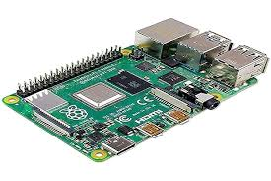

The Raspberry Pi is a series of small single-board computers developed by the Raspberry Pi Foundation. It has gained widespread popularity due to its affordability, versatility, and strong community support. The Raspberry Pi 4 is an advanced version that is well-suited for AIoT applications requiring higher performance.

**Features:**

* Quad-core ARM Cortex-A72 CPU
* Up to 8GB LPDDR4-3200 SDRAM
* Dual-band 802.11ac wireless
* Bluetooth 5.0, BLE
* Gigabit Ethernet
* USB 3.0, HDMI, GPIO

1. **Google Coral Dev Board**

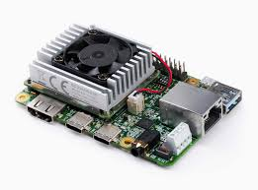

Dev Board is a development board to prototype on-device ML products quickly. TensorFlow Lite models can be compiled to run on the Coral Dev Board.

**Features:**

* NXP i.MX 8M SoC with Quad-core ARM Cortex-A53
* Google Edge TPU coprocessor (up to 4 TOPS)
* 1GB LPDDR4 memory
* 8GB eMMC storage
* Wi-Fi, Bluetooth 4.1
* GPIO, I2C, SPI, UART

**Use Cases:**

* Image classification
* Object detection
* Speech recognition

1. **NVIDIA Jetson Nano**

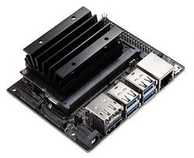

The Jetson Nano module is a small AI computer that gives you the performance and power efficiency to take on modern AI workloads, run multiple neural networks in parallel, and process data from several high-resolution sensors simultaneously. This makes it the perfect entry-level option to add advanced AI to embedded products.

**Features:**

* Quad-core ARM Cortex-A57 CPU
* 128-core Maxwell GPU
* 4GB LPDDR4 memory
* 472 GFLOPS of computational power
* Supports AI frameworks like TensorFlow, PyTorch, Caffe
* Multiple connectivity options: GPIO, I2C, I2S, SPI, UART, USB 3.0, Ethernet

1. **Arduino Nano 33 BLE Sense**

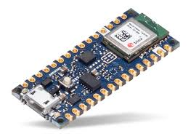

**Features:**

* ARM Cortex-M4 CPU
* 256KB SRAM, 1MB Flash memory, Bluetooth 5.0
* Onboard sensors: temperature, humidity, pressure, gesture, light, color, proximity, microphone, IMU
* 14 digital I/O pins, 8 analog input pins

1. **ESP32 (Low performance Iot Device)**

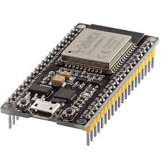

1. **Heltec WiFi LoRa 32 (V2)**
   * **Features**:
     + ESP32 with dual-core LX6 microprocessor
     + LoRa wireless communication
     + OLED display
     + 4MB Flash, 520KB SRAM
     + Wi-Fi, Bluetooth, GPIO, ADC, DAC, I2C, SPI, UART
   * **Use Cases**:
     + Environmental monitoring
     + Remote sensing
2. **M5Stack Core2 ESP32 IoT Development Kit**
   * **Features**:
     + Dual-core ESP32 with Tensilica LX6 processor
     + 2.0" capacitive touch screen
     + 16MB Flash, 8MB PSRAM
     + Wi-Fi, Bluetooth
     + Multiple GPIO ports, I2C, SPI, UART
   * **Use Cases**:
     + User interface-heavy IoT applications
     + AI-enabled devices
3. **Seeed Studio XIAO ESP32S3**
   * **Features**:
     + RISC-V single-core processor
     + Wi-Fi, Bluetooth 5.0
     + 400KB SRAM, 4MB Flash
     + USB Type-C
   * **Use Cases**:
     + Wearable AIoT devices
     + Low-power applications
     + Sensor networks
4. **STM32 Nucleo-144**

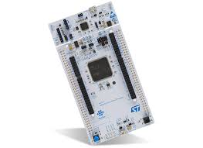

**Features:**

* ARM Cortex-M7 CPU
* Up to 2MB Flash memory, 512KB SRAM
* Ethernet, USB OTG, CAN
* GPIO, ADC, DAC, I2C, SPI, UART
* Expansion connectors for additional modules

1. **BeagleBone AI**

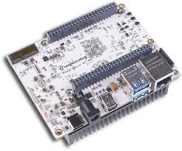

**Features:**

* Dual-core ARM Cortex-A15 CPU
* 2x C66x DSP cores
* 2GB DDR3L RAM, 16GB eMMC storage
* Dual PRU-ICSS for real-time processing
* USB 3.0, Ethernet, HDMI, GPIO

1. **Banana Pi M4 and Orange Pi 4B(similar)**

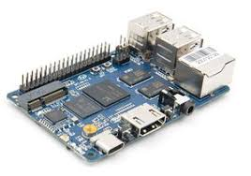

**Features:**

* Realtek RTD1395 SoC with quad-core ARM Cortex-A53
* 1GB/2GB LPDDR4 RAM
* Mali-470 MP4 GPU
* Wi-Fi, Bluetooth, Ethernet
* USB 3.0, HDMI, GPIO

1. **Adafruit Feather M4 Express (Low performance Iot Device)**

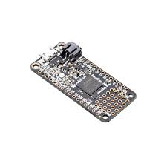

**Features:**

* ARM Cortex-M4 CPU
* 512KB Flash, 192KB RAM
* Native USB, with support for CircuitPython and Arduino
* 20 GPIO pins, analog inputs, I2C, SPI, UART
* Compact size with battery connector

1. **Pine64 RockPro64**

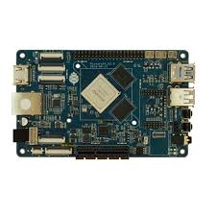

**Features:**

* Rockchip RK3399 SoC with dual-core Cortex-A72 and quad-core Cortex-A53
* Up to 4GB LPDDR4 RAM
* Mali-T860 MP4 GPU
* PCIe x4, USB 3.0, HDMI, GPIO
* Optional AI accelerator module

**11.UP Squared Board**

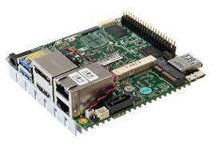

**Features:**

* Intel Atom x5-E3940/x5-E3950 or Pentium N4200
* Up to 8GB LPDDR4 RAM
* Up to 128GB eMMC storage, M.2 slot for SSD
* Intel HD Graphics 500/505
* Gigabit Ethernet, Wi-Fi (via M.2 module), USB 3.0, HDMI, DP, GPIO, I2C, I2S, SPI, UART
* M.2 2230 for Wi-Fi/Bluetooth, M.2 2280 for SSD, and 40-pin GPIO header
* Supports Windows 10, Linux distributions, and Android

**Rithanya K A**

**CB.SC.U4CSE23140**